1. Log into UKG Pro at <https://ew13.ultipro.com/>A screenshot of a computer

   Description automatically generated
2. Click the hamburger icon to open the side navigation menu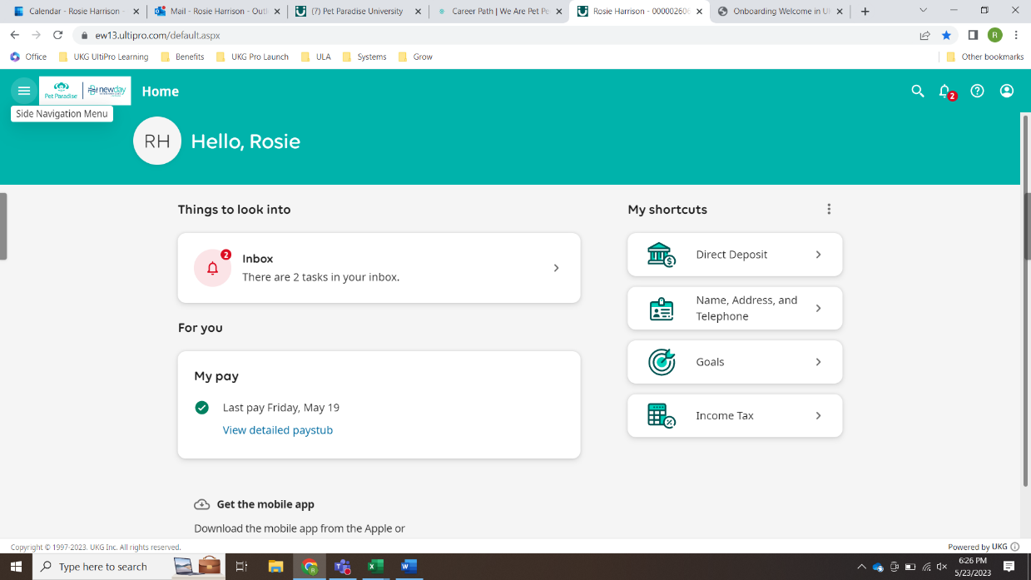
3. Under the myself tab, click UKG Pro Learning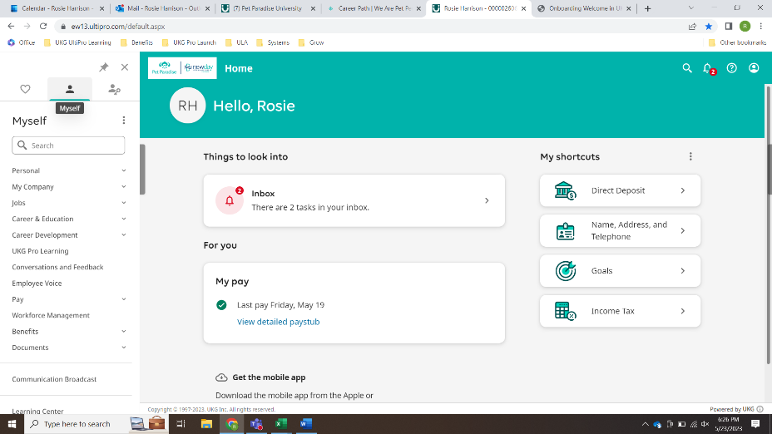
4. Pet Paradise University opens in a new tab, with your required courses listed on the home page